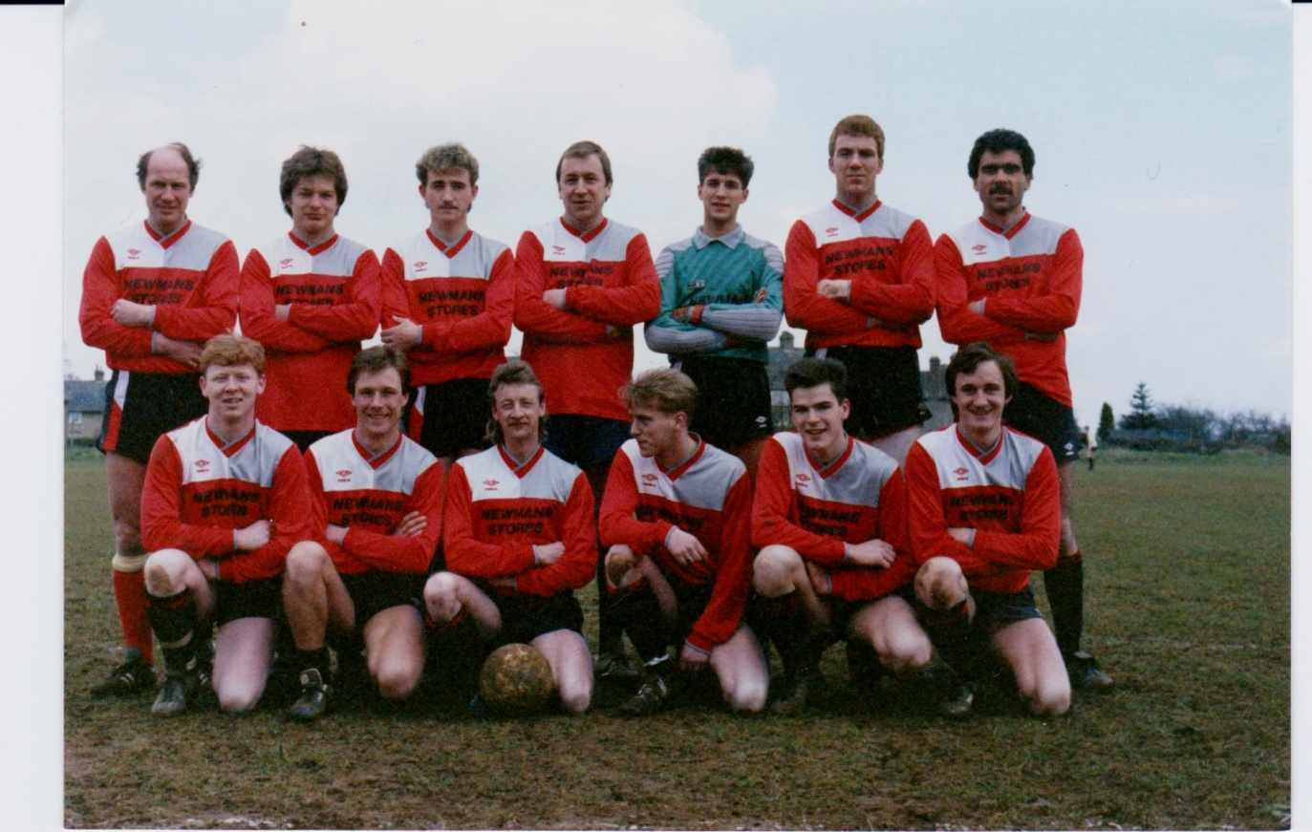

Back Row L/R

Dave Woodcock, Jeremy Boyles , Steve Wilkes, Jeff Sergent, Paul Knight, Barry Cooper, Simon Pratly

Front Row L/R

Stuart Bayliss, Mark Bidwell, Neil Clark, David Knight, Andy Ashton, Duncan Bidwell